Chapter 3.

Fungal Growth

This chapter will describe how fungi grow and obtain nutrients and other resources from the surrounding environment. Fungi are unique organisms that have features not found elsewhere in biology. Therefore it is important as cultivators to understand how fungi grow in hope of encouraging growth of beneficial fungi while inhibiting the growth and presence of fungal pathogens.
There are two main types of growth forms that fungi display; filamentous and yeast. The body of filamentous fungi is made of thin, thread-like, typically cylindrical cells that are extensively branched called hyphae (sing. hypha). These cells allow filamentous fungi to penetrate through substrates. All of the hyphae from an individual fungus is collectively called mycelium (plural mycelia when referring to more than one fungal individual). The mycelium is the vegetative body of the fungus and is the necessary form for the filamentous fungi to collect nutrients and water.
Yeast are single celled fungi, usually spherical, that do not form hyphae. Some fungi can take on a yeast or a filamentous form, depending on the growth stage and environmental conditions. Fungi capable of this versatility in form are referred to as dimorphic.
Yeast forms exist as single cells that replicate via budding or fission, creating two exact genetic copies of itself from a single mother cell. In this way, vegetative growth in yeast is characterized by asexual reproduction of individual cells, rather than growth of a single contiguous hyphal body. Many yeast can also reproduce via sexual replication. Yeast fungi are quite ubiquitous, albeit underappreciated, especially in agriculture settings

Filamentous fungi
Filamentous fungi eat and grow simultaneously. They do so by releasing enzymes ahead and out of the growing hyphal tip, then pushing through their food as they consume it. To coordinate the release of enzymes, filamentous fungi have an organelle-like structure that is called a spitzenkorper at the tip of growing hyphae. This microtubule-dense organizational center delivers vesicles full of enzymes directly outside the growing fungal tip. This external enzyme bath breaks down complex materials into more fundamental, nutritive molecules which are then accessible for endocytosis or direct absorption by the fungus (Steinberg 2014). Additionally, the breakdown of solid substrates clears a path for physical growth of and occupation by the fungus.
Once inside the hyphae, molecules are further broken down and metabolized by the fungus for all of its life functions and growth, including synthesizing proteins, cell walls, hormones, etc.. This is how a fungus ‘eats’, consumes resources, and grows. As the keen mycologist Tom Volk often explains, “it would be as if I went to a 5 star restaurant and ordered the surf and turf (or tofu surprise) and then when the meal came I vomited all over the dish and then stuck my hands over the mess to absorb the nutrients back into my body.” Quite the image.
Another physical trait that some filamentous fungi possess is having septa. Septa are crosswalls that some fungi produce behind the growing tip in order to divide the hyphae into different ‘cells’. These septa are perforated, allowing some organelles to pass while blocking others. Because many groups of fungi allow the movement of so much of their cellular contents, sometimes including nuclei, the individuality of each cell isn’t always clearcut.
There are two different types of septa that are found in fungi; simple porate septa and dolipore septa. These different septa morphologies can be used to distinguish the phylum that the fungus is located in. Fungi in the phylum Basidiomycota have what is called a dolipore septum, often along with a clamp connection. This type of septum has membranes covering the central pores, allowing for the fungus to maintain its dikaryotic state (2 types of nuclei per cell) while still allowing small organelles and chemicals to flow through with the cytoplasm.
Septa are partitions between fungal cells, but in some fungi, these septa lack membranes that would typically block organelles, such as nuclei, from passing between cells. This allows for the free flow of organelles across cells. Some fungal groups, like Zygomycota (bread molds), Glomeromycota (endomycorrhizae), and Chytridiomycota (which includes the pathogen causing chytridiomycosis), lack septa altogether, or have them only occasionally, and are termed coenocytic or aseptate.
In coenocytic fungi, where there are no septa, the organism functions as a single, multinucleate cell. The hyphal tips, where growth is highest, often have a high concentration of nuclei, indicating a need for gene products in these areas. This cellular structure enables fungi to exchange nuclei and cytoplasm with compatible fungi, leading to genetic variation within a single individual. This type of genetic exchange provides fungi with phenotypic plasticity, enhancing their ability to adapt to their environment. It also serves as a source of genetic diversity, which can drive fungal evolution, especially in fungi that do not reproduce sexually. Such exchanges can even occur between distantly related fungal species, further contributing to genetic novelty.

Some filamentous fungi will produce a fruiting body collectively called a mushroom. A mushroom is simply a reproductive structure that certain fungi have evolved to produce. In general, edible mushroom producing fungi are not physiologically involved with Cannabis. However, some applications of mushroom producing species may be beneficial in Cannabis agriculture. For example, Pleurotus osreatus, the common oyster mushroom, can be cultivated on the dead biomass of Cannabis plants (the stems, the leaves). Another example of a mushroom producing fungus that aids in Cannabis cultivation is Stropharia rugosa-annulata or the garden giant (aka wine cap). This fungus is particularly good at decomposing organic materials such as wood chips or straw and is commonly inoculated in garden beds. In addition, planting mushrooms near cash crops also recruits other biology to the soil system. Using the garden giant will help aid in nutrient cycling, improve soil structure, and may release compounds that influence plants and/or soil biology. https://www.ncbi.nlm.nih.gov/pmc/articles/PMC4358370/
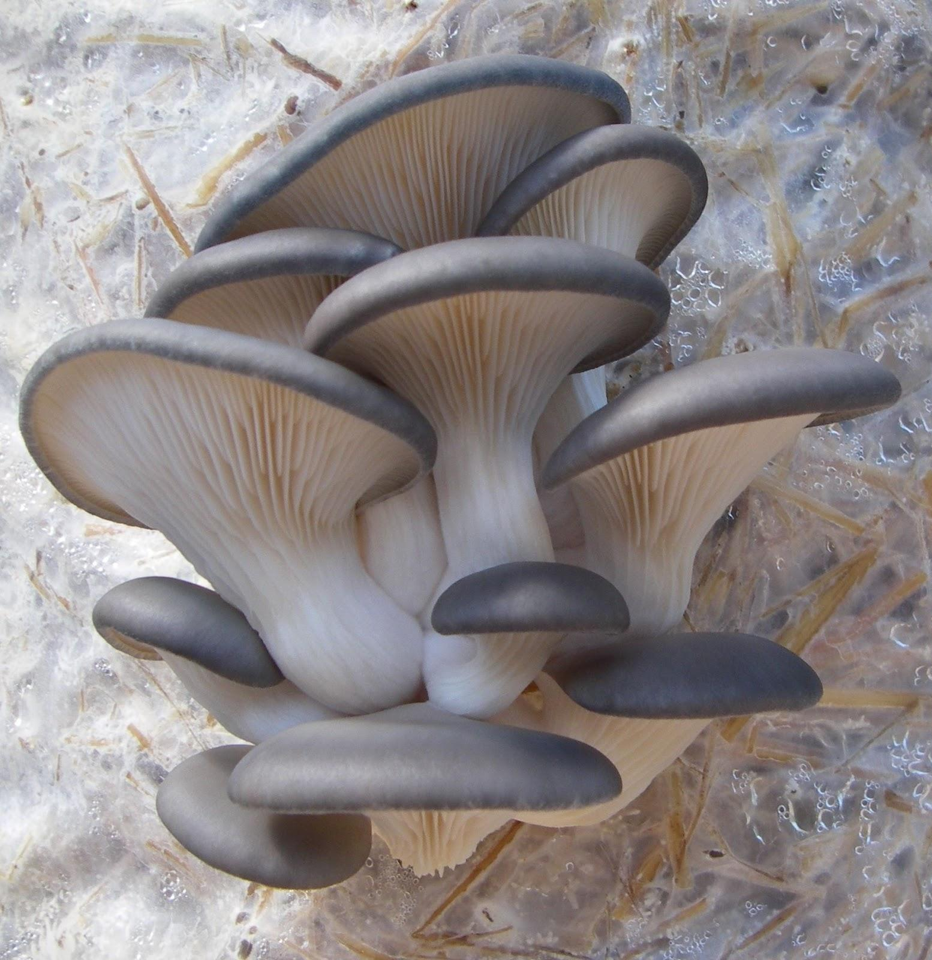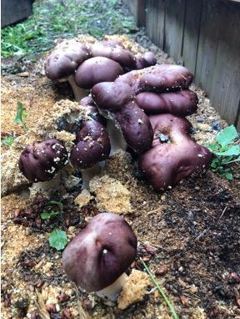
3.1a Oyster mushroom fruiting off straw. 3.1b Wine cap fruiting out of soil.

Currently there is some misinformation going around in the Cannabis industry in relation to soil fungi and compost tea. There have been claims by some who say that if a fungus has septa, then the fungus is beneficial and will help with decomposition and plant growth. However, if the fungus does not have septa (coenocytic), then it is a pathogenic fungus and will kill plants and harm your soil community. While there are some instances where this may be true, this is a broad over-generalization and septa alone should not be used to identify beneficial vs pathogenic fungi. Possibly, what people are referring to is Oomycetes, or water molds, which are coenocytic, pathogenic, and are also not true fungi. Many useful and beneficial fungi lack septation, including members of the Glomeromycota, and Zygomycota.

Yeast Fungi
Yeast fungi are single-celled organisms that are often too small to be seen without a microscope. They are found everywhere in various habitats across the globe. One of the most well-known yeasts is Saccharomyces cerevisiae, commonly used in brewing and baking. This species, with its various strains, has a long history of use by humans. Additionally, Saccharomyces cerevisiae is a valuable model organism for scientific research due to its ease of cultivation and resilience. However, not all yeasts are beneficial—some, like Cryptococcus neoformans, can cause serious diseases in humans, including cryptococcosis, and can also be endophytes of plants like Cannabis.
Yeasts are difficult to identify through simple observation under a microscope. While some may show unique physiological traits, many require metabolic testing or molecular techniques for accurate identification. Despite their small size and often unnoticed presence, yeasts play an important role in soil and agriculture. They help decompose organic matter, serve as a food source for other organisms, produce valuable metabolites, influence plant growth, and contribute to soil structure.
Conclusions
Fungi either grow as a unicellular yeasts, have a filamentous body of hyphae collectively called mycelium, or may switch between these forms. Filamentous growth offers certain advantages over yeast forms for the performance of particular tasks. The absorptive eating strategy employed by fungi benefits from a highly branched, fast expanding body with favorable surface ratio for the exploitation of an abundant food resource. As digestive enzymes released from the growing tip of the fungus, the hyphal body can absorb the products of the substrates decomposition via endocytosis.
Filamentous fungi may also differentiate into specialized structures and have complex patterns of nutrient transport and metabolic coordination. This can be particularly useful when claiming territory and food resources over long periods of time. Some filamentous fungi can grow perennial structures that persist and function for years and even decades. However, being small and simple in design has its benefits as well. Yeasts are capable of reproducing at an extraordinary rate. Because they are just a single cell, everything the organism needs to survive and reproduce is kept in every cell.
As you can see, fungi can be quite diverse in appearance both macroscopically and microscopically. While these differences have proven useful as diagnostic features for the identification and classification of organisms, the true utility of these features is to allow fungi to specialize and exploit various ecological niches. Now let us explore further how fungi live, grow, and gather nutrients from their environment.
In summary:
· Fungi can grow as a yeast or in a filamentous form, sometimes both
· Fungi do not produce their own food so must release enzymes to break down complex food sources, then ingest the predigested nutrients into their bodies
· Filamentous fungi grow from the apical tips to eat food and colonize new spaces

